

Payments



BRS GOLF Payments Module 3
Payments 3
Payouts 4
Booking Payment Requests 4
General Payment Requests 4
Transaction Reports 4
VAT Reports 4
Recognizing an online payment 6
Sending a Booking Payment Request by Link 7
Send Payment Link 8
Pay Now 8
General Payment Requests 9
Refunds 10
Installation and setup 11



BRS GOLF Payments Module
Collect and manage all your payments directly from BRS GOLF with our new Payments Module. Our payments solution has been specifically designed for golf clubs and allows you to manage all your online transactions through BRS Golf. Allow members and visitors to easily pay bills and green fees online with our completely secure payments processor, seamlessly integrated with our Visitor Booking Engine, Tee Sheet, Memberships software and more.
Through Payments you can process online and over the phone transactions, as well as competition purse top-ups. Now you can even request payment via email by sending a link to your customers and allowing them to pay online at their convenience. Particularly handy for societies and large groups.
No more logging into your merchant account – manage everything in one place with BRS GOLF.


Payments
Within your Tools menu, you will find a new BRS Payments tool containing the key elements where you can control your setup, view transaction and VAT reports, and view and process refunds for online payments.
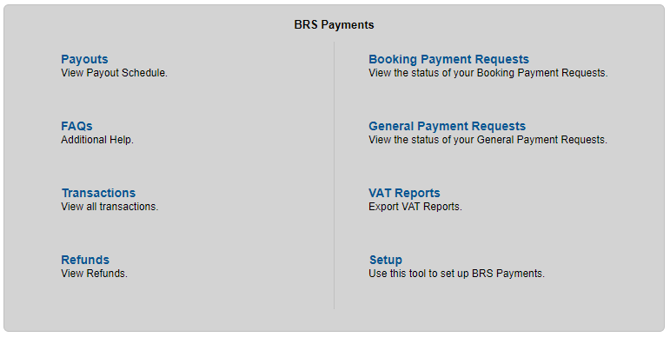

Payouts refers to the schedule of payouts from BRS Golf to your club bank account, so you can track when you are receiving payment for your bookings. Payouts to the golf clubs bank account are controlled by golf now but we will set these up to automatically payout on a 7-day rolling basis.
The Payouts report will display payments by source including Memberships Bill Payments, Wallet top-ups, Payment Requests, Visitor Booking and Purse Top-ups.
If you wish to view the individual transactions of each payout, you can click directly on the Amount to view further details. Each booking will have an associated fee allowing you to tally what is charged in each payout. Payouts can be downloaded as a CSV or printed.
Booking Payment Requests - BRS Payments contains a wholly new feature to BRS - the ability to send a Payment Request email to a contact, containing a link for the customer to pay a pre-defined amount for their tee time booking. We hope this will be a major improvement on the age-old need to chase the likes of societies for deposit cheques / instalment cheques
General Payment Requests - The ability to send a Payment Request email to a contact or member, containing a link for the customer to pay a pre-defined amount online. This is different to booking payment requests as it can be used to more generally to take a payment for any purpose you wish e.g. Membership, Fees, Pro Shop.
Transaction Reports allow you to view any transactions made within a 7 day window. This section also allows admin users the option to refund a transaction by clicking on the "More" button on the left hand side. Once a transaction has been refunded, an '*' will appear beside the amount in the 'Gross Amount' column.

VAT Reports
The VAT reports are useful in providing a snapshot of a months’ worth of transactions. Each VAT report is broken down detailing:
- Reference Number
- Date
- Type
- Gross Sales
- Processing Fees
- Net Sales
- VAT
Each VAT report can be downloaded to a PDF file or as a CSV.

Visitors will now have the convenience of being able to prepay in full for their tee time through the BRS Visitor Booking Engine on your club website.
This improved minimal and responsive checkout experience with Payments means visitors can pay directly and easily on any device.
Requirements:
- Long card number
- Date of expiry in MM/YY format e.g. for February 2023 it would be 02/23
- CVC- Short code on back on card
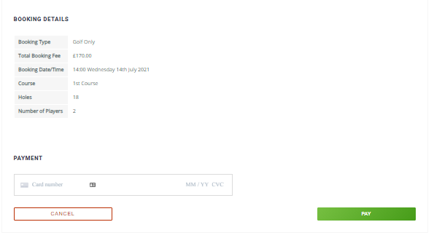



Recognizing an online payment
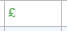
Bookings which are fully paid will be shown with a Green currency symbol on the timesheet. Partially paid will appear in Blue. Fully outstanding will be in Red. Overpayment would be in Yellow.

Within the booking details you will see the Payment Method as ‘BRS Payment’.
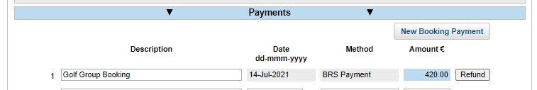

Within Reports, you will now have access to reports on revenue on payments which are built to help you report on online payments, including Revenue from Online Merchant Payments.



Sending a Booking Payment Request by Link
Within your BRS Timesheet, click on a tee time and open the Booking Details screen. Click on Payments, you will see a “New Booking Payment” button.
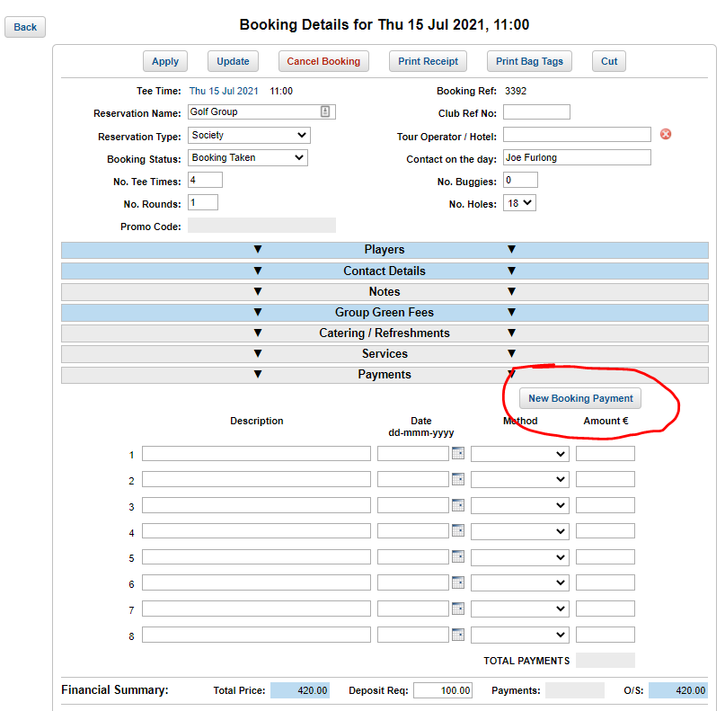
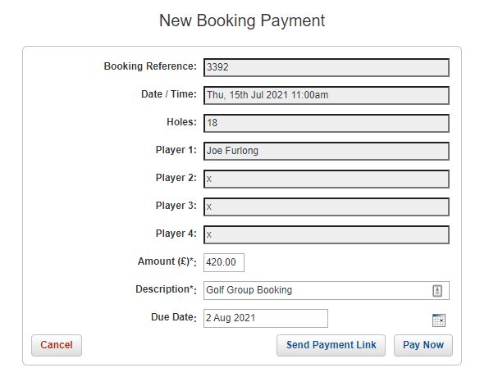
Booking details are automatically filled out, including the outstanding balance in the Amount (£/€) field.

This window gives the admin two payment options, ‘Send Payment Link’ or ‘Pay Now’.

Send Payment Link allows you to email the customer a link that they can use to make a payment to the club at their own convenience. You can edit the default “Payment Request” text here and attach documents.
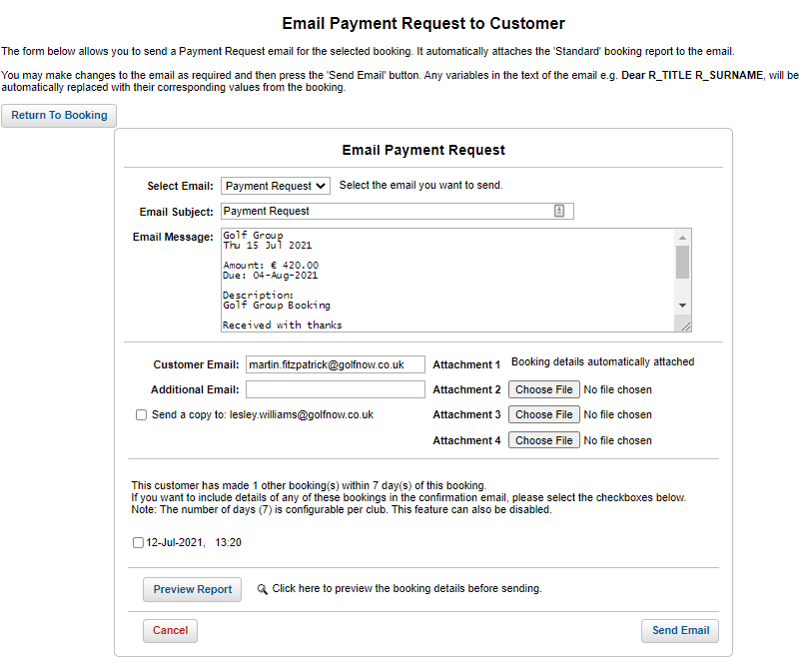
Pay Now allows the admin to take a card payment though a virtual terminal, where an admin would key in the card details provided by the customer on the form shown.
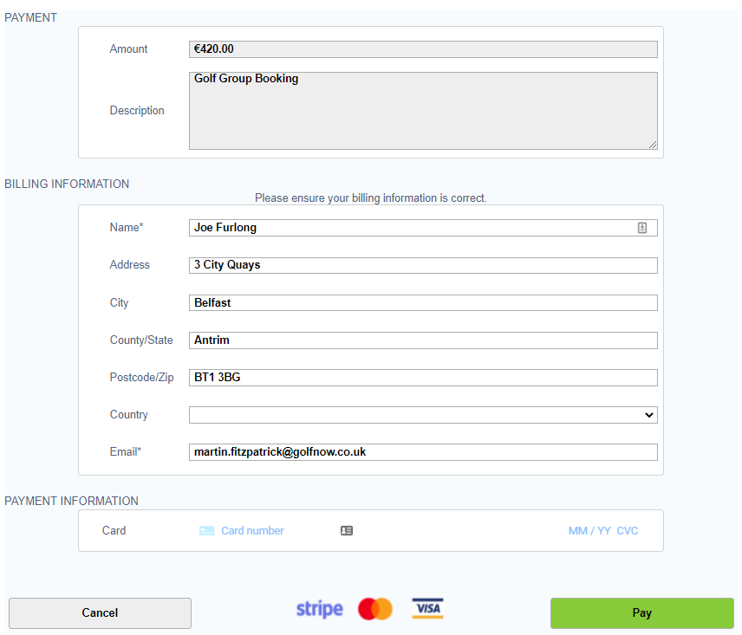

General Payment Requests
We have included a means of sending Payment Request emails for charges that are not specifically related to a golf booking. It is the ‘General Payment Requests’ Tool located under the Tools menu of BRS.
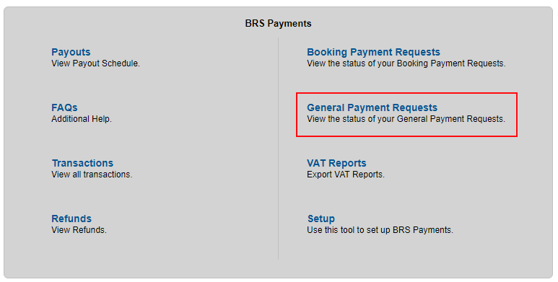
- Click the General Payment Requests Tool.
- On the next page you can search for existing requests or click the ‘Create Payment Request’ to add a new one.
- Complete the short form to create & send a payment request.
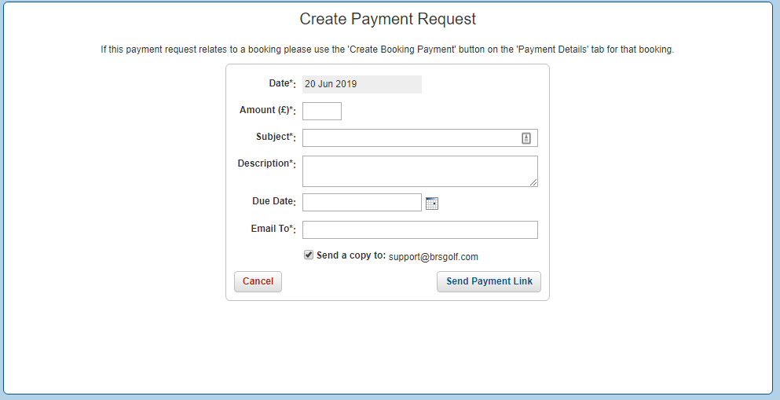
General Payment Requests are ideal for taking payments for the likes of room hire & other miscellaneous fees and charges.



Refunds
Providing a refund for an online payment for a green fee is simple. From the timesheet, go to the date and tee time of the booking. Click on the tee time to open the Booking Details screen.
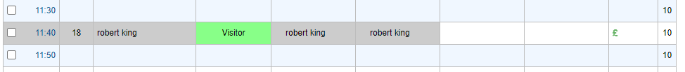
Click in the Payments tab to expand it and view payments made on this booking. Locate your payment by description, date, and amount. Payments made online will be displayed with the Payment Method ‘BRS Payment’. To the right, click ‘Refund’.
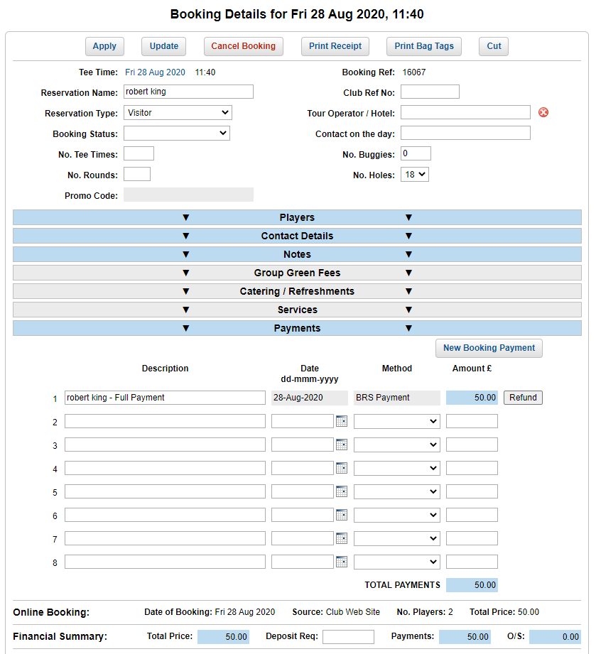

For partial refunds, simply type in the Amount to be refunded.
Finally, click Refund which transfers the payment back to the customer.
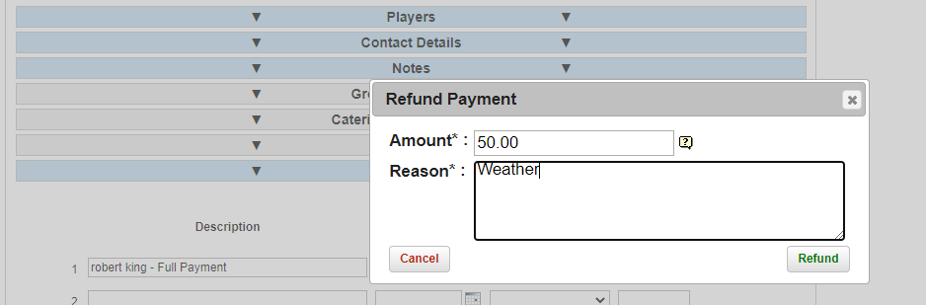

Please allow 5-10 days for refunds to return to the customer account. To retrieve a record of all refunds, go back to the Tools menu and under 'Payments', select 'Refunds'.
Payments recorded manually, e.g., via Cash will not have the Refund option available.
Please note: Refunds for Membership bill payments can only be completed in full.



Installation and setup
‘Payments’ is simple to set up. Confirm with your Account Manager at BRS Golf that you would like to proceed, and we will request that you complete a short agreement confirming the terms.
We can have you set up and taking payments in minutes. Our customer support team only need a few things to get started:
- Business registration document, e.g. VAT registration certificate
- Bank Detail
- Account Owner / Representative’s Identification document e.g. Photo of Driver’s License
To sign up for Payments simply contact us:
UK: 028 9568 0288
IE: 1800 852 935
Email: support@golfnow.co.uk

